**ITA1445-ETHICAL HACKING**

**Lab Experiments**

**Name: D. Asritha**

**Admin no: 192121042**

EXPNO:1

Aim:To perform various port scanning such as TCP , UDP , ACK, SYN using Nmap in Kali Linux operating systems.

Procedure:

Step 1: Open Nmap from Kali Linux (Goto Applications->select Information Gathering->select

Nmap)

Step 2: Perform different types of scan

(Tcp, Udp, Ack, Syn, Fin, Null, Xmas, Rpc, Idle)- scan types

Scanning Techniques

Flag Use Example

-sS TCP syn port scan nmap -sS 192.168.1.1

-sT TCP connect port scan nmap -sT 192.168.1.1

–sU UDP port scan nmap –sU 192.168.1.1

–sA TCP ack port scan nmap –sA 192.168.1.1

Out Put:

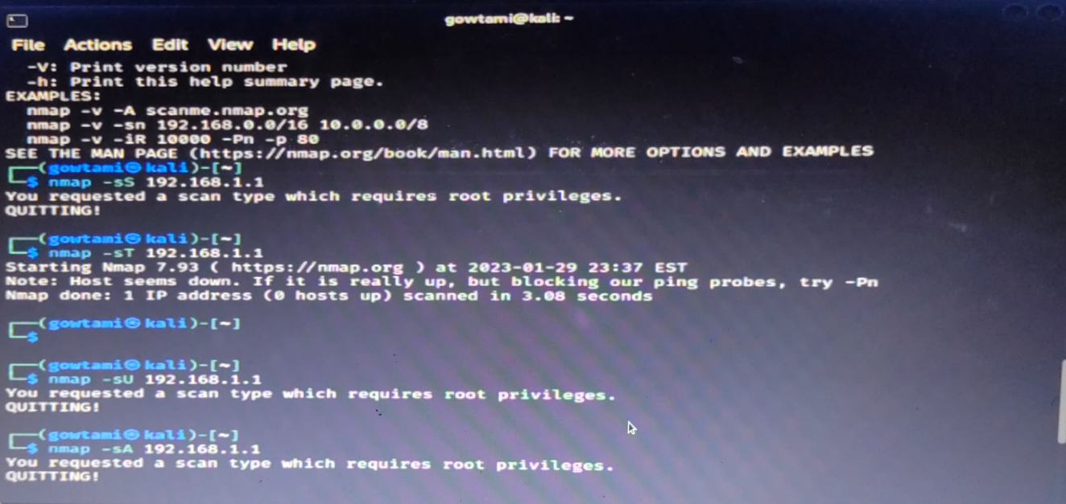

Result:Out put is verified Succesfully.

EXP NO:2

Aim: To perform various host Discovery scanning using Nmap in Kali Linux operating systems.

Procedure:

Step 1: Open Nmap from Kali Linux (Goto Applications->select Information Gathering->select

Nmap)

Step 2:

To perform host discovery

-Pn only port scan nmap -Pn192.168.1.1

-sn only host discover nmap -sn192.168.1.1

-PR arp discovery on

a local network nmap -PR192.168.1.1

-n disable DNS resolution nmap -n 192.168.1.

Out Put:

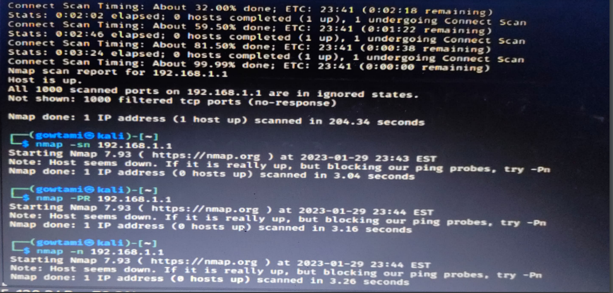

Result: Out put is verified Succesfully.

EXP NO:4

Aim: To demonstrate information gathering using theHarvester command in Kali Linux operating systems.

Procedure:

STEP 1: Open Terminal in the kali linux

Step 3: run this command “theHarvester -d www.zoho.com -l 300 -b all -f test” and hit enter to export the result as html file and xml file

Step 4: now close the terminal and navigate the home folder and search for test file

Out Put:

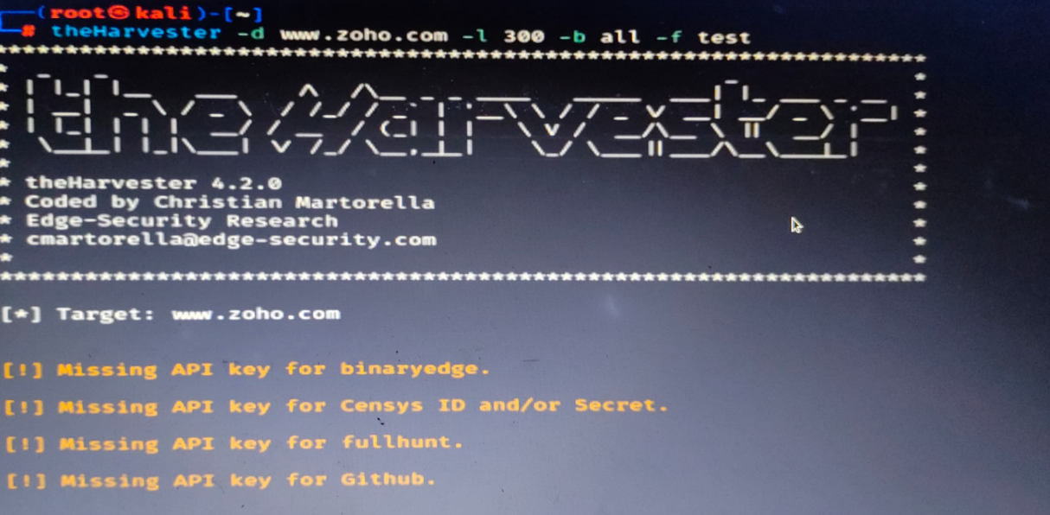

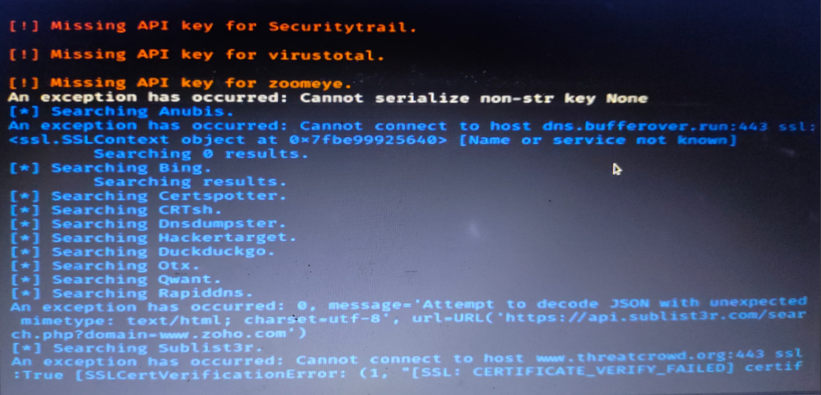

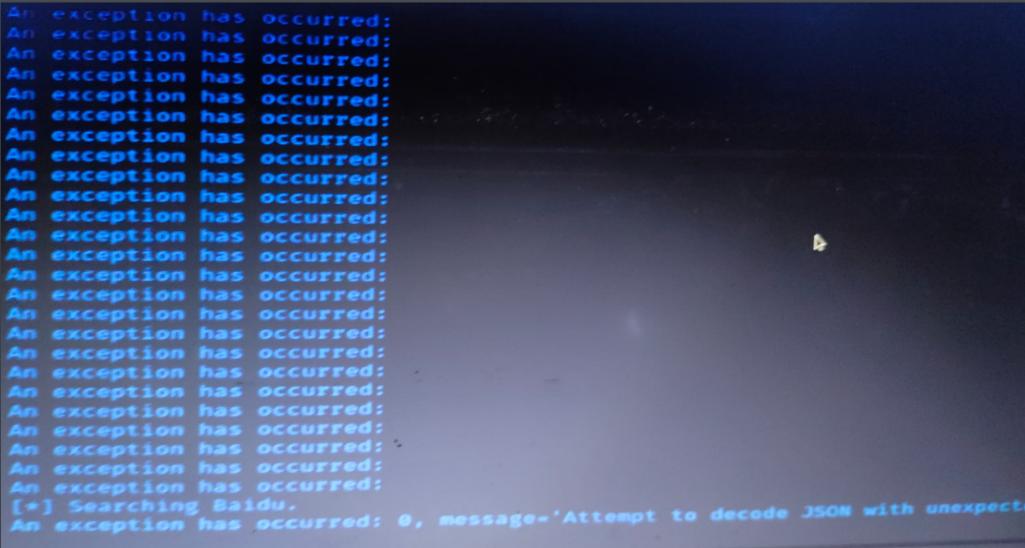

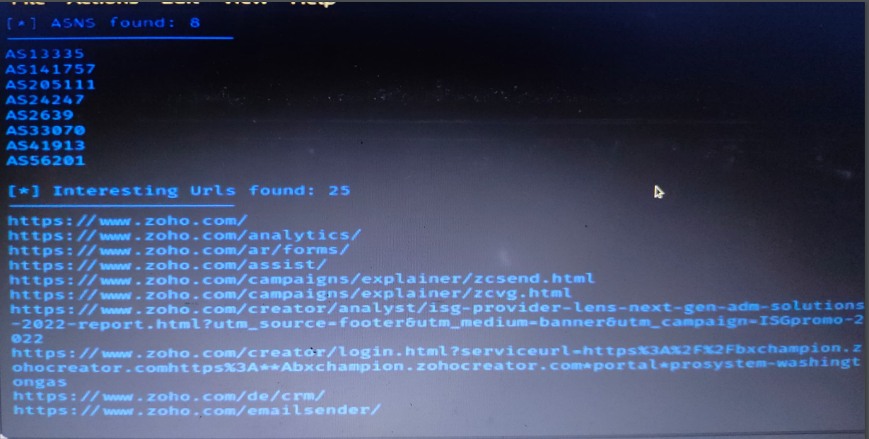

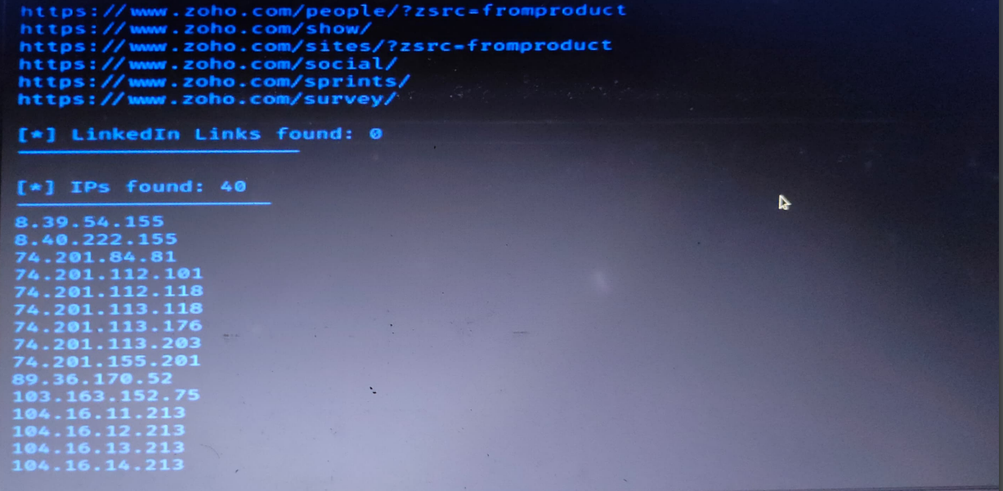

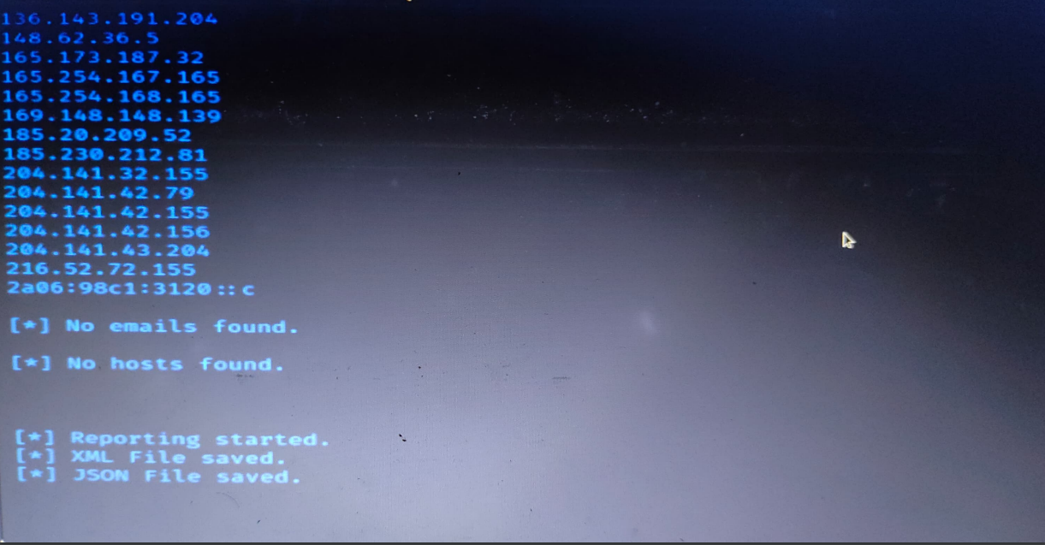

Result: Out put is verified Succesfully.

EXP NO:5

Aim: To find out the Whois, DNS Records and Diagonstics for particular website by using Whois search in windows operating systems.

Procedure:

Step1: Open the WHO.is website

Step 2: Enter the website name in search bar and hit the “Enter button”.

Step 3: Show you information about [www.saveetha.com](http://www.saveetha.com)

Out Put:

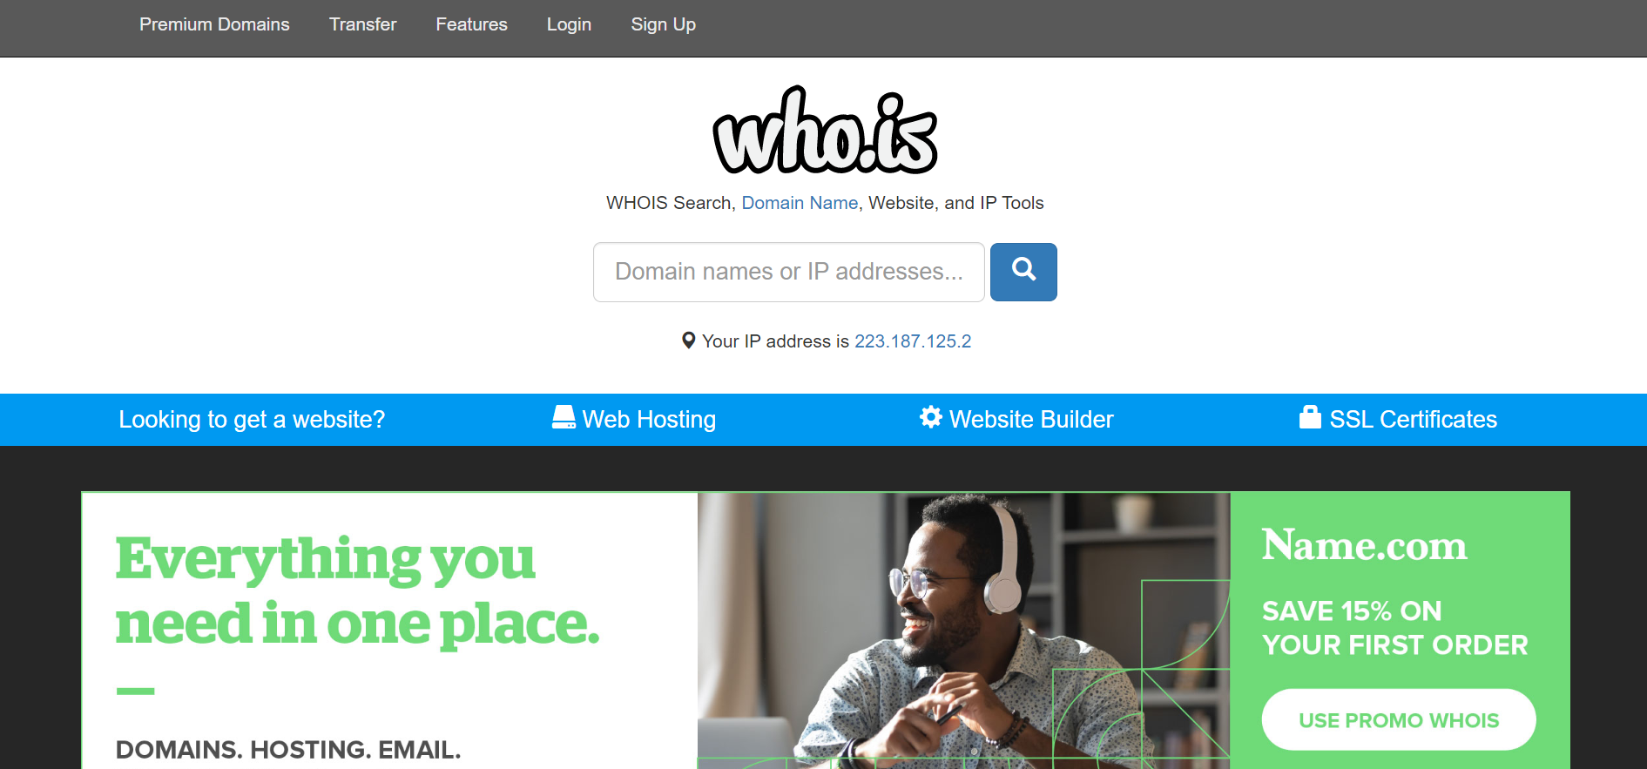

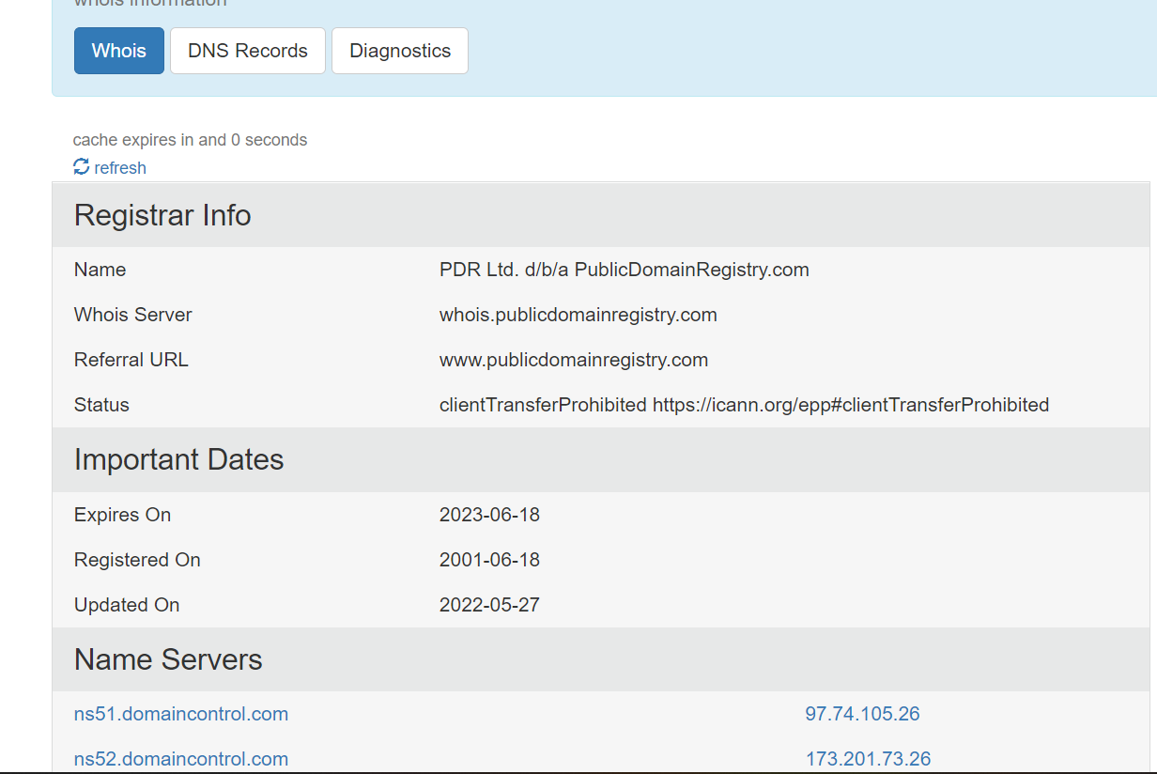

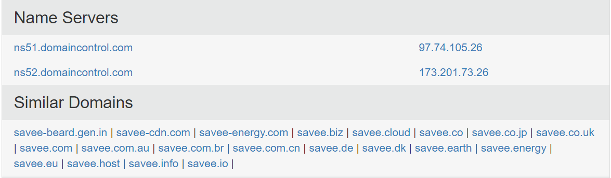

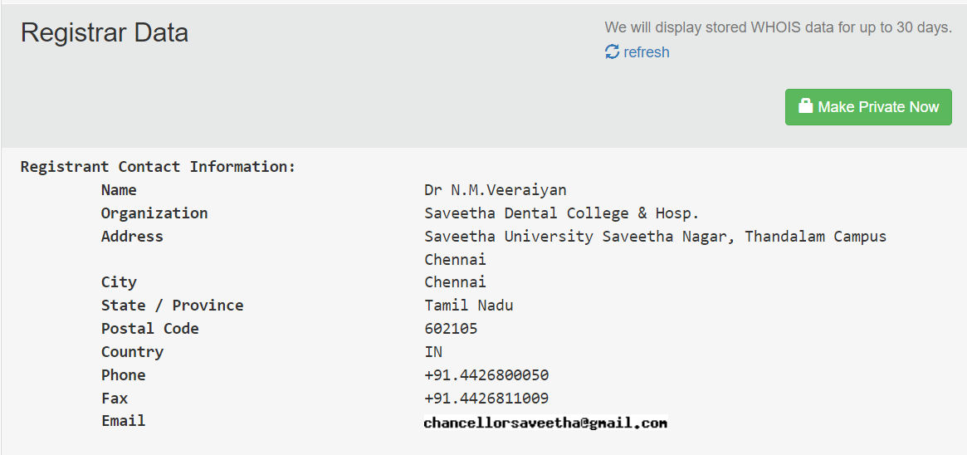

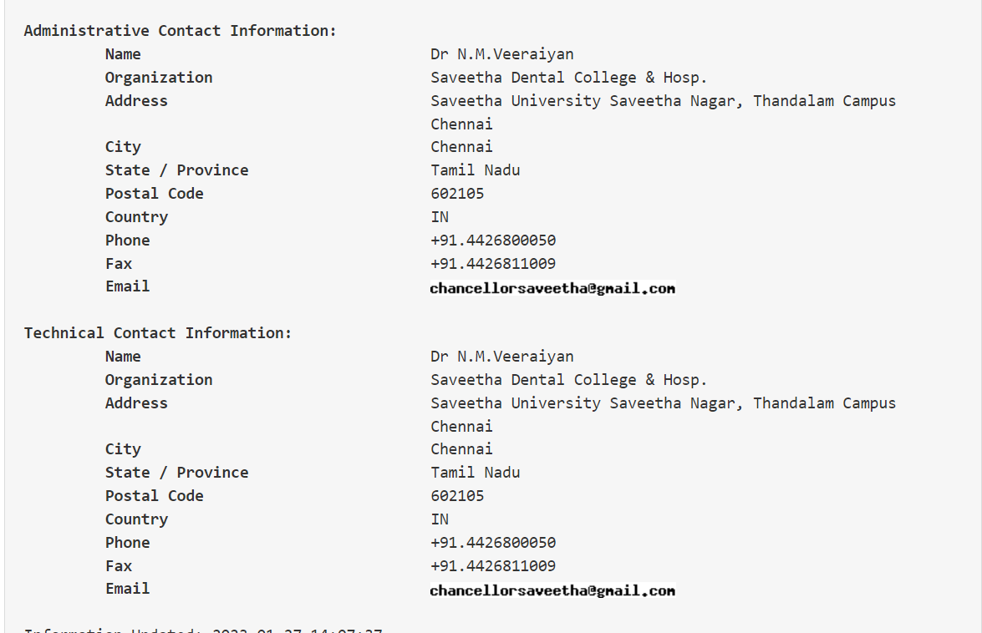

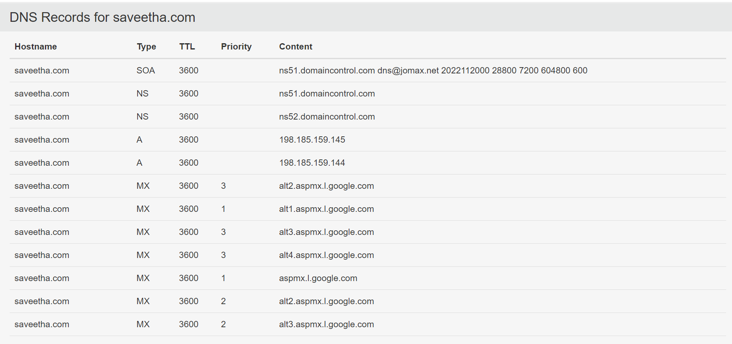

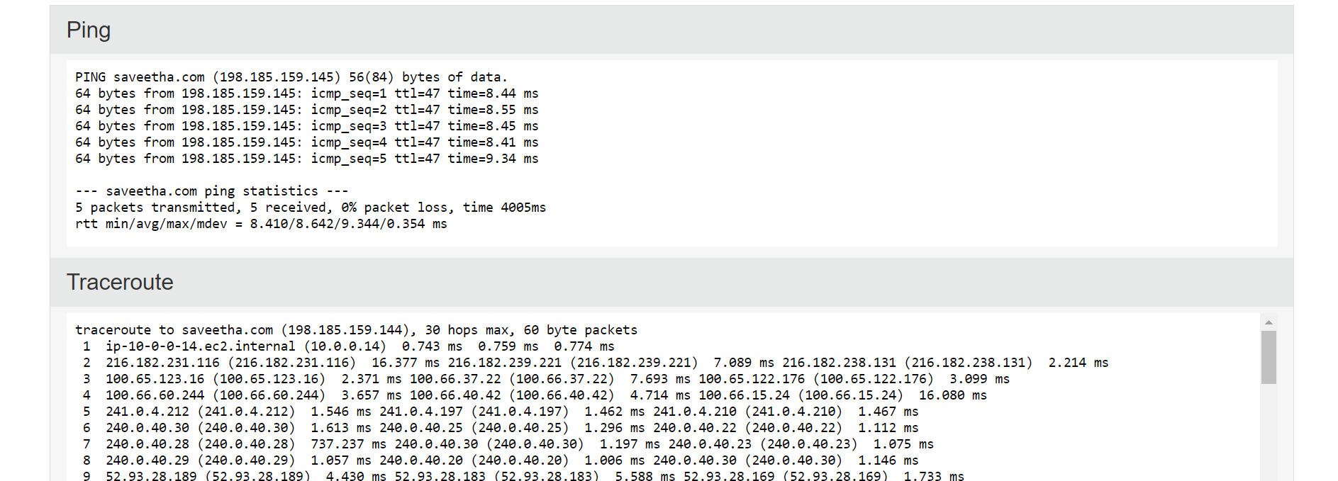

Result: Out put is verified Succesfully.

EXP NO:6

Aim: To execute the following command in windows operating systems traceroute, ping and ifconfig

Procedure:

Step 1: open windows command prompt and Type tracert command and type tracert www.saveetha.com -> “Enter”

Step 2: Type ping command and type IP Address press “Enter

Step 3: Type ifconfig command

Out Put:

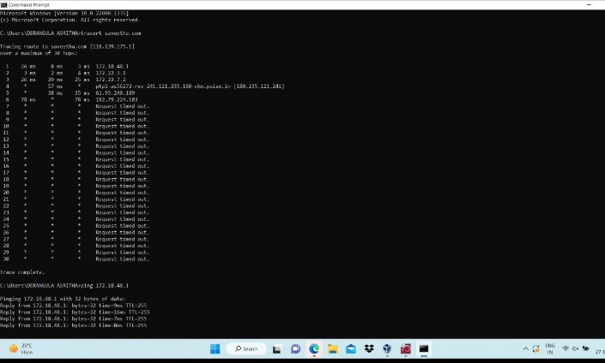

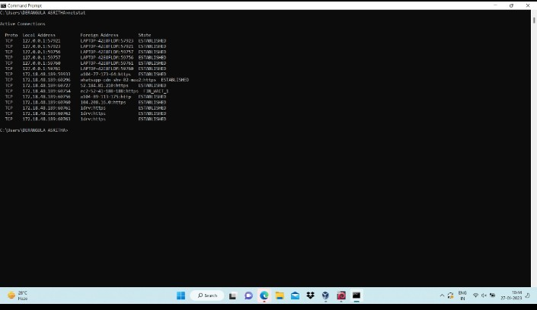

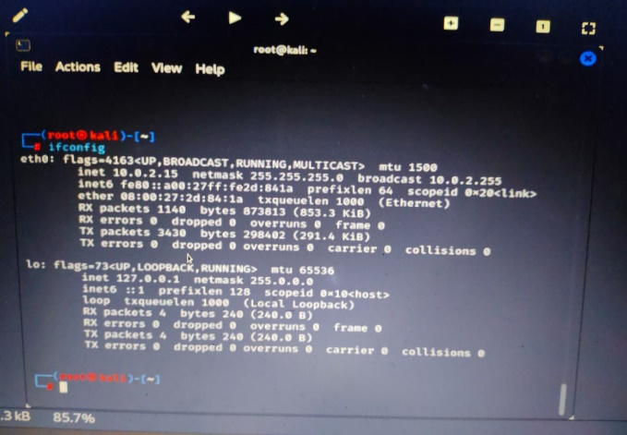

Result: Out put is verified Succesfully.

EXP NO:7

Aim: To execute the following command in windows operating systems ipconfig(WINDOWS), and netstat

Procedure:

Step 1: Type ifconfig command

Step 2: Type netstat command

Out Put:



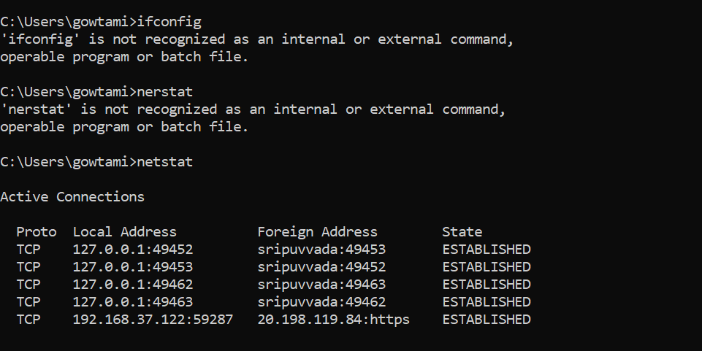

Result: Out put is verified Succesfully.

EXP NO:8

Aim: To perform vulnerability Analysis using CGI Scanning with Nikto in Kali Linux operating systems

Procedure:

Step 1: open a terminal window and type nikto –H and press enter

Step 2: Type nikto –h Tuning x and press enter

Step 3: Nikto starts web server scanning with all tuning options enabled.

Step4:In the terminal window type “nikto –h -Cgidirs all”and hit enter

Step 5. Nikto will scan the webserver as it looks vulnerable CGI directories. It scans the webserverand list out the directories

Out Put:

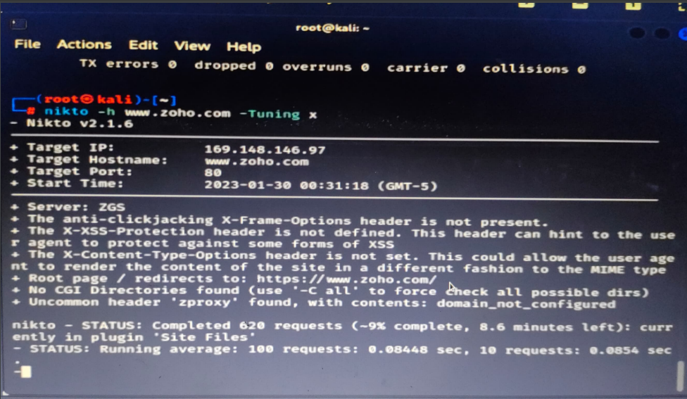

Result: Out put is verified Succesfully

EXP NO:9

Aim: Use WireShark sniffer to capture network traffic and analyze

Procedure:

Step 1: Download wireshark

Step 2: select one inter face.

Step 3:Packets will appear.

Step 4:Open url and search something.

Step 5:Get back to wire shark and capture the packets.

Out Put:

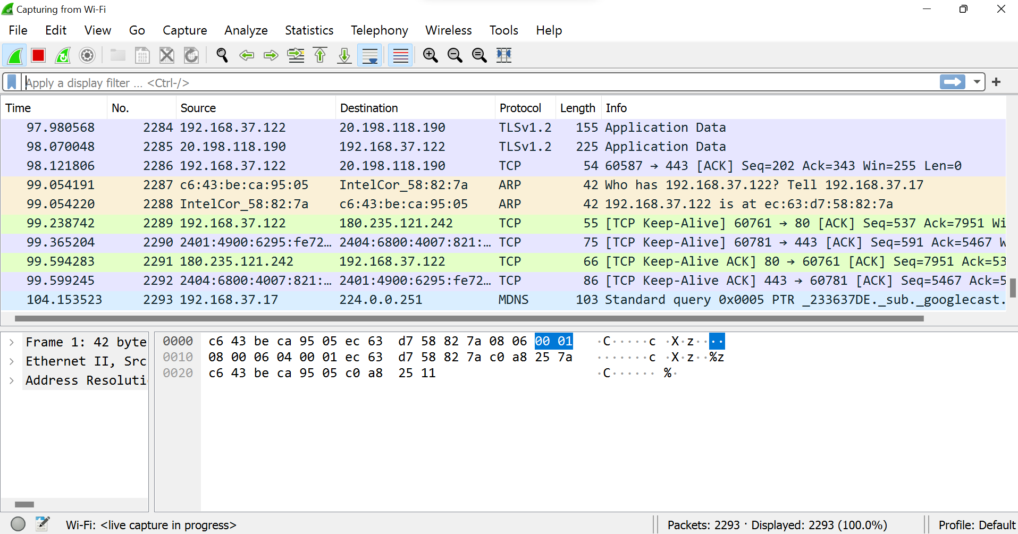

Result: Out put is verified Succesfully

EXP NO:11

Aim: To create a Batch file in windows operating systems

Procedure:

Step 1:Open text editor in windos.

Step 2:

@echo off

echo hello

Pause

echo This is new

echo this is second one

pause

Step 3:Save the file with extension “.bat”.

Step 4:Double click on the saved file.

Out Put:

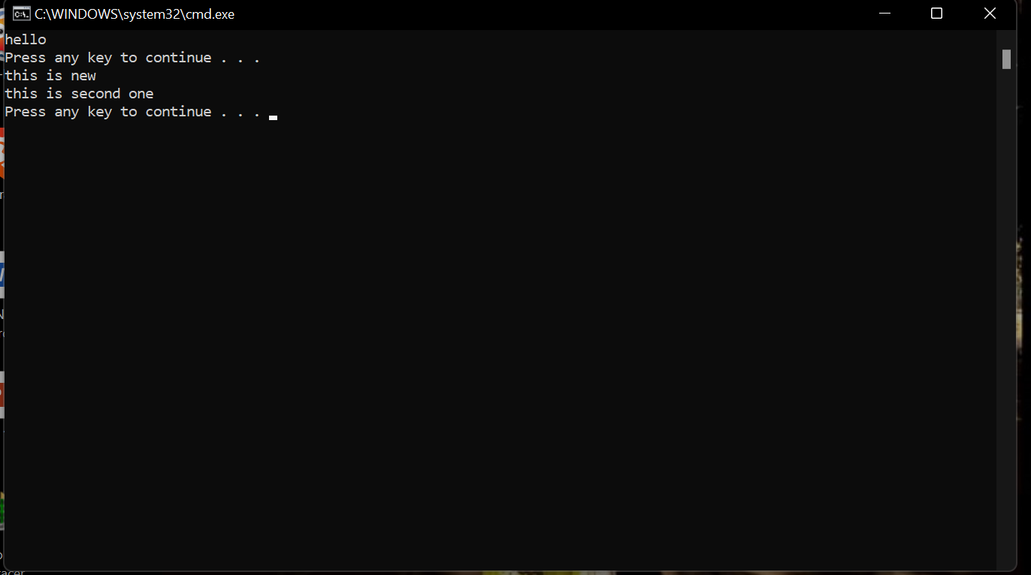

Result: Out put is verified Succesfully

EXP NO:12

Aim: To analyse the network packet transmission using packet analyser tool.

Producer:

Step 1:Install wire shark.

Step 2:select an inter face.

Step 3:Capture packet list pane

Packet bytes pane

Packet details pane

Out Put:

packet list pane

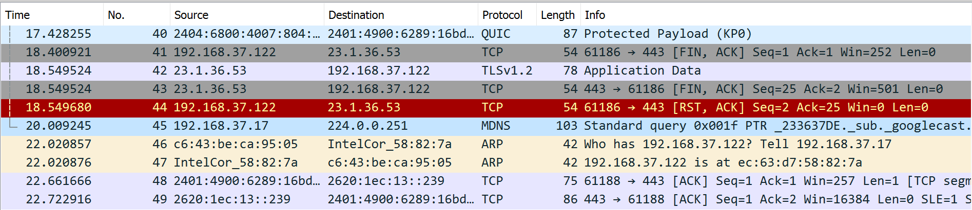

Packet bytes pane

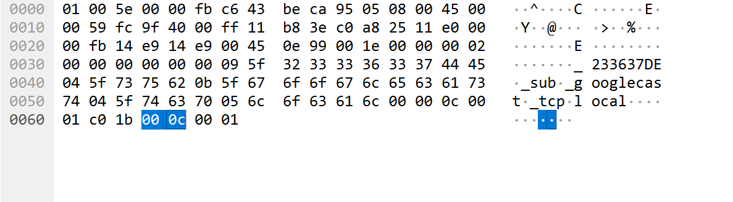

Packet details pane

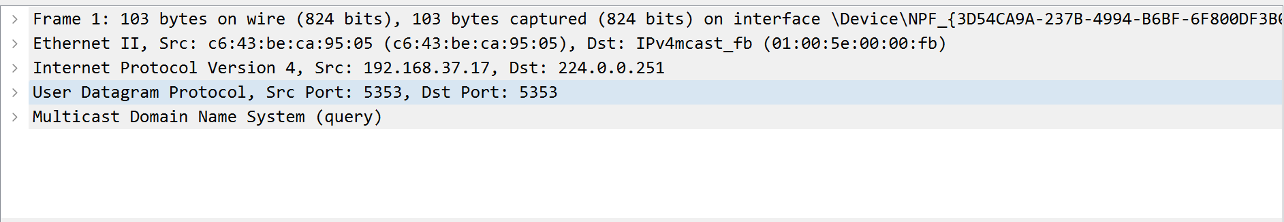

Result: Out put is verified Succesfully

EXP NO:13

Aim: How to specify the port scanning using Nmap in Kali Linux operating systems.

Procedure:

Step 1: Open Nmap from Kali Linux (Goto Applications->select Information Gathering->select Nmap)

Step 2:

Port Specification

Flag Use Example

-p specify a port or port range nmap -p 1-30 192.168.1.1

-p- scan all ports nmap -p- 192.168.1.1

F fast port scan nmap -F 192.168.1.1

Out Put:

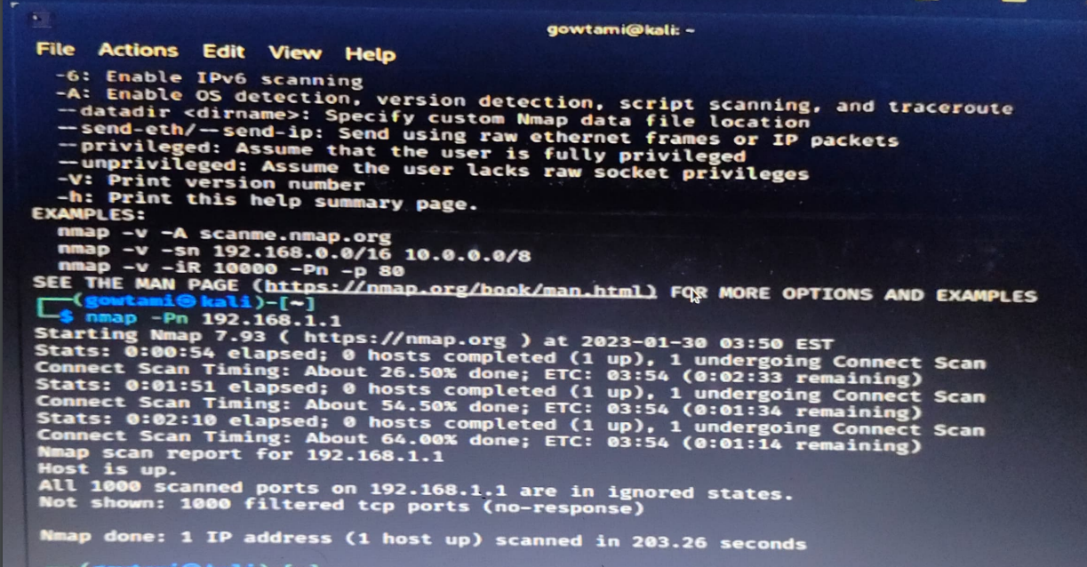

Result: Out put is verified Succesfully

EXP NO:14

Aim: By using different flag to find out the timing performance of scanning in kali linux operating systems.

Procedure:

Step 1: Open Nmap from Kali Linux (Goto Applications->select Information Gathering->select Nmap)

Step 2:

Timing and Performance

Flag Use Example

-T0 paranoid IDS evasion nmap -T0 192.168.1.1

-T1 sneaky IDS evasion nmap -T1 192.168.1.1

-T2 polite IDS evasion nmap -T2 192.168.1.1

-T3 normal IDS evasion nmap -T3 192.168.1.1

-T4 aggressive speed scan nmap -T4 192.168.1.1

Out Put:

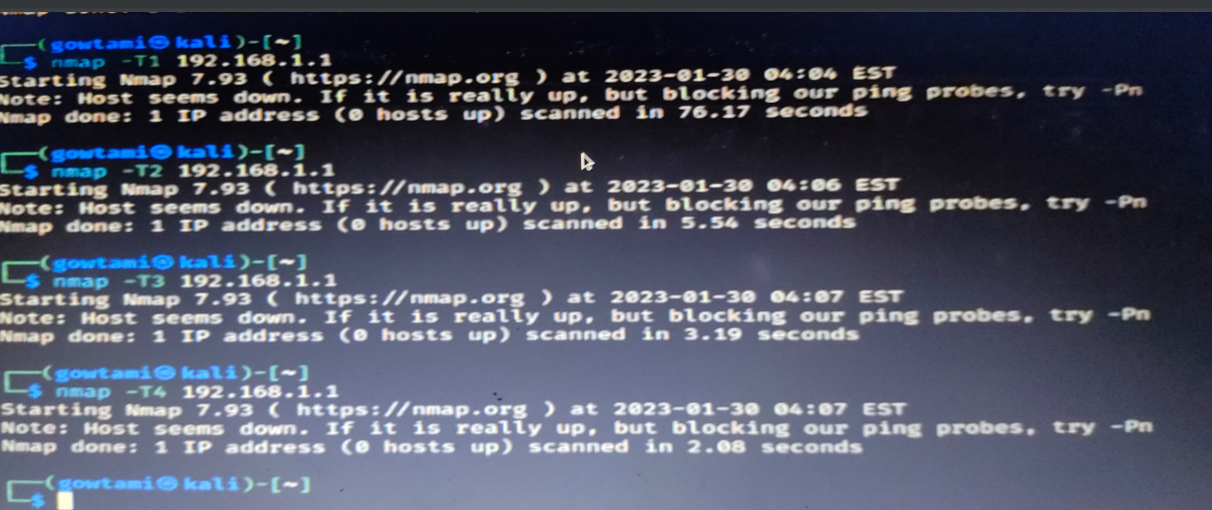

Result: Out put is verified Succesfully

EXP NO:18

Aim: To execute the following command in windows operating systems traceroute and ifconfig

Procedure:

Step 1:Open command promt in windows.

Step 2:enter the command tracerout and ifconfig.

Out Put:

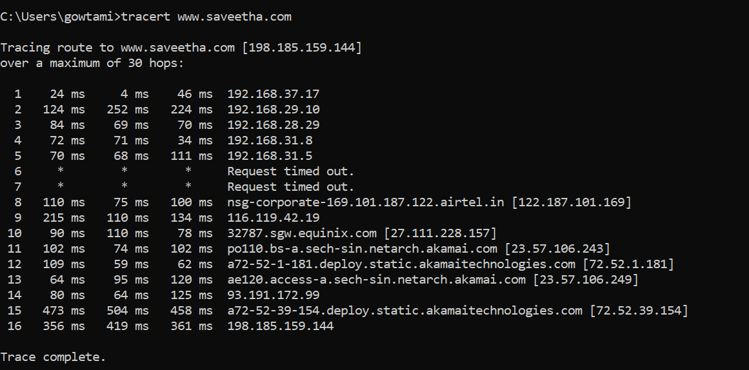

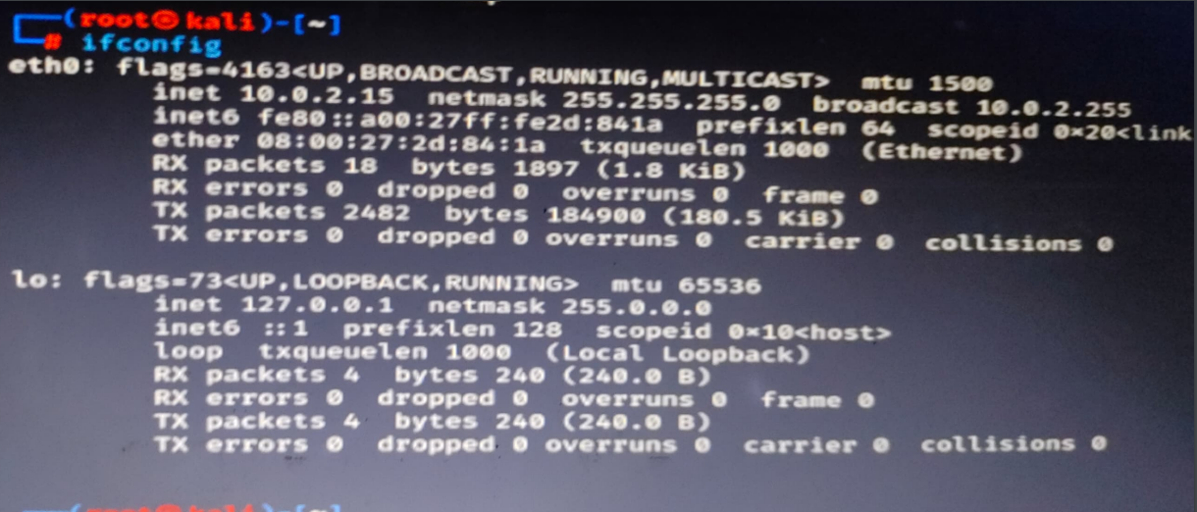

Result: Out put is verified Succesfully